UART – **Serial**, Slide 6

void setup() {

**Serial**.begin(9600);

}

void loop() {

**Serial**.println("Hello! What's your name?");

while ( !**Serial**.available() ) {}

delay(100);

**Serial**.print("Hello there ");

int i;

for( i=**Serial**.available(); i>0; i-- ) {

char input = **Serial**.read();

**Serial**.print(input);

}

**Serial**.println("!");

}

I2C – **Wire** Library, Slide 12

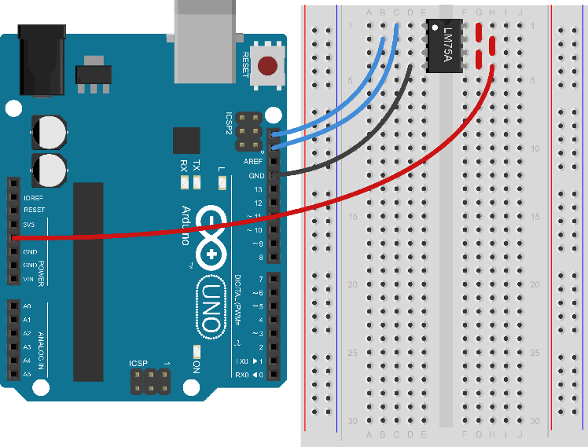

#include <Wire.h>

const int address = 79;

void setup() {

**Serial**.begin(9600);

Wire.begin();

}

void loop() {

Wire.requestFrom(address, 2);

word temp = Wire.read();

temp = temp << 8;

temp = temp + Wire.read();

temp = temp >> 5;

**Serial**.println(temp*0.125);

}

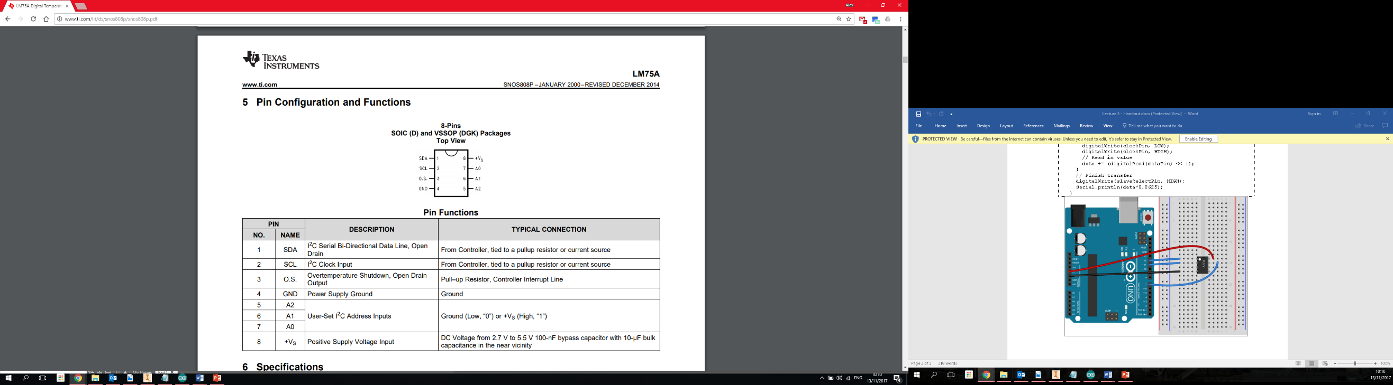

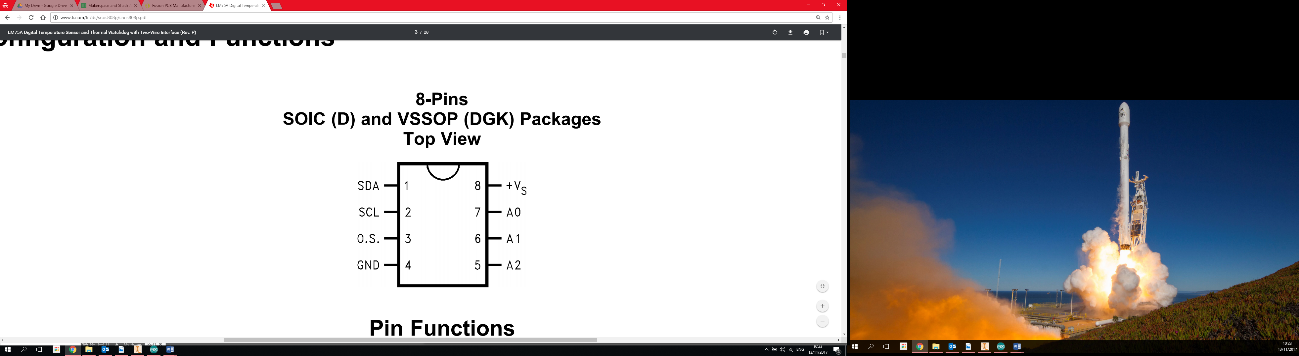

SPI – **SPI** Library, Slide 16

#include <**SPI**.h>

const int ss = 10;

void setup() {

**Serial**.begin(9600);

**SPI**.begin();

pinMode(ss, OUTPUT);

digitalWrite(ss, HIGH);

}

void loop() {

digitalWrite(ss, LOW); //Chip Enable

**SPI**.beginTransaction( SPISettings(7000000, MSBFIRST, SPI_MODE3) );

word temp = **SPI**.transfer16(0); //Read Data

**SPI**.endTransaction();

digitalWrite(ss, HIGH); //Chip Disable

temp = temp >> 3;

**Serial**.println(temp*0.0625);

}

